React Notes
What is React?
React is a free, open-source JavaScript library developed by Meta Platforms for building fast, interactive, and reusable user interfaces (UI), especially for Single Page Applications (SPAs).
It allows developers to create applications by breaking the UI into small, reusable components, making code easier to maintain and reuse.
Definition (Interview Answer)
React is a JavaScript library used to build fast, interactive, and reusable user interfaces. It uses a component-based architecture, Virtual DOM, and one-way data binding to efficiently update the UI.

Key Features of React
- Component-Based Architecture
  - Build the UI using reusable components.
  - Example: Header, Navbar, ProductCard, Footer.
- Virtual DOM
  - React creates a virtual copy of the real DOM.
  - When data changes, React updates only the changed elements instead of reloading the entire page, improving performance.
- JSX (JavaScript XML)
  - Allows you to write HTML-like syntax inside JavaScript.
function App() {
return <h1>Hello React!</h1>;
}
- One-Way Data Binding
  - Data flows from the parent component to child components through props.
  - This makes applications easier to understand and debug.
- Reusable Components
  - Write a component once and use it multiple times.
- Declarative UI
  - You describe what the UI should look like based on the current state, and React updates the DOM automatically.

What is Virtual DOM? (In Depth)
The Virtual DOM (VDOM) is a lightweight copy of the Real DOM that React keeps in memory.
Instead of updating the browser's Real DOM directly whenever data changes, React first updates the Virtual DOM, compares it with the previous version, and then updates only the changed parts of the Real DOM.
This makes React applications faster and more efficient.
What is DOM?
DOM (Document Object Model) is a tree-like representation of an HTML document created by the browser.
Example HTML:
<body>
<div>
<h1>React</h1>
<button>Click</button>
</div>
</body>
DOM Tree:
Document
|
html
|
body
|
div
/ \
h1 button
JavaScript can manipulate this DOM.
Example:
document.querySelector("h1").innerText = "Hello";
The browser updates the page immediately.

Problem with Real DOM
Updating the Real DOM is expensive because:
- Browser has to find the element.
- Update it.
- Recalculate layout.
- Repaint the screen.
- Sometimes reflow the page.
Imagine a page with 1000 products.
If only one product price changes, updating the entire DOM repeatedly would waste resources.

What is Virtual DOM?
Virtual DOM is simply a JavaScript object that represents the UI.
Example:
<h1>Hello</h1>
React converts it into something like:
{
type: "h1",
props: {
children: "Hello"
}
}
This object lives in memory and is very fast to create and compare.

How Virtual DOM Works
Suppose we have:
function App() {
return <h1>Hello</h1>;
}
React creates Virtual DOM:
Virtual DOM
App
|
h1
|
Hello
Browser renders:
Real DOM
App
|
h1
|
Hello
Everything is synchronized.

Now Data Changes
Suppose state changes.
Before:
<h1>Hello</h1>
After:
<h1>Hello Abhishek</h1>
React creates another Virtual DOM.
Old Virtual DOM
h1
|
Hello
New Virtual DOM
h1
|
Hello Abhishek
React compares both trees.
This process is called Diffing.

Diffing Algorithm
React compares:
Old
<h1>Hello</h1>
New
<h1>Hello Abhishek</h1>
It detects:
✔ h1 is same
Only text changed.
Instead of replacing the whole element:
❌ Remove h1
❌ Create new h1
It simply changes:
Hello
↓
Hello Abhishek
Only one update.

Reconciliation
The process of updating the Real DOM after comparing Virtual DOMs is called Reconciliation.
Flow:
State Changes
↓
New Virtual DOM
↓
Compare Old vs New
(Diffing)
↓
Find Changes
↓
Update Real DOM
↓
Browser Paint

Example
function App() {
const [count, setCount] = useState(0);
return (
<>
<h1>{count}</h1>
<button onClick={() => setCount(count + 1)}>
Increment
</button>
</>
);
}
Initially
Virtual DOM
h1
|
0
button
|
Increment
Click button.
New Virtual DOM
h1
|
1
button
|
Increment
Comparison
Old
0
New
1
Only text changed.
React updates:
0
↓
1
Button remains exactly the same.

Another Example
Products:
Product 1
Product 2
Product 3
User changes Product 2 price.
Old
100
200
300
New
100
250
300
Virtual DOM detects only:
200
↓
250
Only Product 2 updates.

Why Virtual DOM is Faster
Without React:
Change Data
↓
Update Real DOM
↓
Layout
↓
Paint
With React:
Change Data
↓
Virtual DOM
↓
Diff
↓
Only Changed Nodes
↓
Real DOM
↓
Paint
Much less work is done on the browser.

Virtual DOM vs Real DOM
Real DOM | Virtual DOM
Actual DOM in the browser | Lightweight JavaScript representation of the DOM
Slow to update | Fast to create and compare
Direct DOM manipulation | Updates the Virtual DOM first
Causes layout and repaint | Minimizes browser work
Browser handles it | React manages it

Difference Between Library and Framework
The main difference between a library and a framework is who controls the flow of the application.

Library | Framework
You call the library when you need it. | The framework calls your code.
You have control over the application flow. | The framework controls the application flow.
It provides specific functionality. | It provides a complete structure for building applications.
More flexible. | More opinionated with predefined rules and structure.

React Components, Props, and JSX (In Depth)
These are the three most fundamental concepts in React. If you understand them well, you'll find it much easier to build React applications.

1. Components
What is a Component?
A component is a reusable piece of UI.
Instead of writing one large HTML file, React lets you split the UI into small, independent pieces called components.
Think of a webpage like a car:
- 🚗 Car
  - Engine
  - Wheels
  - Doors
  - Seats
Each part has its own responsibility.
Similarly, a React application is made up of components.
Example:
App
│
├── Navbar
├── Sidebar
├── ProductList
│ ├── ProductCard
│ ├── ProductCard
│ └── ProductCard
├── Footer
Each component can be reused wherever needed.

Types of Components
1. Functional Components (Modern)
These are the recommended way to write React components.
function Welcome() {
return <h1>Hello React</h1>;
}
export default Welcome;
Arrow function:
const Welcome = () => {
return <h1>Hello React</h1>;
};
export default Welcome;

2. Class Components (Older)
import React, { Component } from "react";
class Welcome extends Component {
render() {
return <h1>Hello React</h1>;
}
}
Today, functional components with Hooks are the standard approach.

Why Components?
Without components:
Header
Sidebar
Products
Footer
Everything is written in one file.
With components:
Header.tsx
Sidebar.tsx
ProductCard.tsx
Footer.tsx
Benefits:
- Reusable
- Easy to maintain
- Easy to test
- Better readability
- Less code duplication

Component Example
ProductCard.tsx
const ProductCard = () => {
return (
<div>
<h2>iPhone 16</h2>
<p>$999</p>
</div>
);
};
export default ProductCard;
App.tsx
import ProductCard from "./ProductCard";
function App() {
return (
<>
<ProductCard />
<ProductCard />
<ProductCard />
</>
);
}
Output:
iPhone 16
$999
iPhone 16
$999
iPhone 16
$999
The same component is reused three times.

Component Lifecycle (Functional Components)
Component Created
↓
Rendered
↓
Updated (state/props change)
↓
Unmounted
Hooks like useEffect let you perform actions during these stages.

2. Props
What are Props?
Props (Properties) are used to pass data from a parent component to a child component.
Props are read-only, meaning a child component should not modify them.
Think of props like function parameters.
Function example:
function greet(name) {
console.log(name);
}
greet("Abhishek");
name is a parameter.
Similarly:
<ProductCard title="iPhone" />
title is a prop.

Parent Component
<ProductCard
title="iPhone 16"
price={999}
/>

Child Component
type Props = {
title: string;
price: number;
};
const ProductCard = ({ title, price }: Props) => {
return (
<div>
<h2>{title}</h2>
<p>${price}</p>
</div>
);
};
Output:
iPhone 16
$999

Multiple Props
<ProductCard
title="Samsung"
price={899}
category="Mobile"
/>
Child:
type Props = {
title: string;
price: number;
category: string;
};
const ProductCard = ({ title, price, category }: Props) => {
return (
<>
<h2>{title}</h2>
<p>{price}</p>
<p>{category}</p>
</>
);
};

Passing Objects
const product = {
title: "Laptop",
price: 1000,
};
<ProductCard product={product} />
Child:
type Product = {
title: string;
price: number;
};
type Props = {
product: Product;
};
const ProductCard = ({ product }: Props) => {
return (
<>
<h2>{product.title}</h2>
<p>{product.price}</p>
</>
);
};

Passing Arrays
const fruits = ["Apple", "Banana", "Orange"];
<List items={fruits} />
Child:
type Props = {
items: string[];
};
const List = ({ items }: Props) => {
return (
<ul>
{items.map((item) => (
<li key={item}>{item}</li>
))}
</ul>
);
};

Passing Functions
Parent:
const handleClick = () => {
alert("Clicked");
};
<Button onClick={handleClick} />
Child:
type Props = {
onClick: () => void;
};
const Button = ({ onClick }: Props) => {
return <button onClick={onClick}>Click</button>;
};

Props are Read-Only
❌ Wrong
props.title = "Laptop";
Props should never be modified by the child component.

Data Flow
Parent
↓
Props
↓
Child
React uses one-way data binding, so data always flows from parent to child.

3. JSX
What is JSX?
JSX (JavaScript XML) is a syntax extension for JavaScript that lets you write HTML-like code inside JavaScript.
Example:
<h1>Hello React</h1>
This looks like HTML but is actually JSX.

Without JSX
const element = React.createElement(
"h1",
null,
"Hello React"
);

With JSX
const element = <h1>Hello React</h1>;
JSX is easier to read and write.

JSX is Converted
<h1>Hello</h1>
becomes:
React.createElement(
"h1",
null,
"Hello"
);
This conversion is handled during the build process (e.g., by Babel).

Embedding JavaScript
Use {} inside JSX.
const name = "Abhishek";
return <h1>Hello {name}</h1>;
Output:
Hello Abhishek

Expressions
const a = 10;
const b = 20;
return <h1>{a + b}</h1>;
Output:
30

Conditional Rendering
const isLogin = true;
return (
<>
{isLogin ? <h1>Welcome</h1> : <h1>Please Login</h1>}
</>
);

Rendering Lists
const fruits = ["Apple", "Banana", "Orange"];
return (
<ul>
{fruits.map((fruit) => (
<li key={fruit}>{fruit}</li>
))}
</ul>
);
Output:
Apple
Banana
Orange

Attributes
HTML:
<input class="box">
JSX:
<input className="box" />
Some common differences:
HTML | JSX
class | className
for | htmlFor
onclick | onClick
tabindex | tabIndex

Self-Closing Tags
HTML:
<img>
JSX:
<img src="image.jpg" alt="Example" />
All tags without children must be self-closing.

One Parent Element
❌ Incorrect:
<h1>Hello</h1>
<p>React</p>
✅ Correct:
<>
<h1>Hello</h1>
<p>React</p>
</>
or
<div>
<h1>Hello</h1>
<p>React</p>
</div>

Relationship Between Components, Props, and JSX
App Component
│
├── Navbar Component
│
├── ProductCard Component
│ ↑
│ │
│ Receives Props
│
└── Footer Component
All UI is written using JSX.
- Components split the UI into reusable pieces.
- Props pass data from parent to child.
- JSX is the syntax used to describe the UI.

Difference Between Class Components and Functional Components
React components can be written in two ways:
- Class Components (Older approach)
- Functional Components (Modern and recommended)
Today, functional components with Hooks are the standard approach in React.

Comparison Table
Class Components | Functional Components
Introduced first in React | Introduced from the beginning, but became powerful with Hooks in React 16.8
Written using ES6 classes | Written as JavaScript functions
Extend React.Component | No need to extend any class
Use this keyword | No this keyword
State managed using this.state | State managed using useState Hook
Lifecycle methods like componentDidMount() | useEffect Hook replaces lifecycle methods
More boilerplate code | Less code and easier to read
Harder to understand and maintain | Easier to understand and maintain
Less preferred in modern React | Recommended approach

1. Class Component
import React, { Component } from "react";
class Welcome extends Component {
render() {
return <h1>Hello React</h1>;
}
}
export default Welcome;
Characteristics
- Uses ES6 class
- Must extend React.Component
- Must have a render() method
- Uses this

2. Functional Component
function Welcome() {
return <h1>Hello React</h1>;
}
export default Welcome;
Or using an arrow function:
const Welcome = () => {
return <h1>Hello React</h1>;
};
export default Welcome;
Characteristics
- Simple JavaScript function
- No render() method
- No this
- Easier to write

State Example
Class Component
import React, { Component } from "react";
class Counter extends Component {
state = {
count: 0,
};
render() {
return (
<>
<h1>{this.state.count}</h1>
<button
onClick={() =>
this.setState({
count: this.state.count + 1,
})
}
>
Increment
</button>
</>
);
}
}

Functional Component
import { useState } from "react";
function Counter() {
const [count, setCount] = useState(0);
return (
<>
<h1>{count}</h1>
<button
onClick={() => setCount(count + 1)}
>
Increment
</button>
</>
);
}
The functional version is shorter and easier to understand.

Lifecycle Methods
Class Component
class App extends Component {
componentDidMount() {
console.log("Component Mounted");
}
componentDidUpdate() {
console.log("Updated");
}
componentWillUnmount() {
console.log("Unmount");
}
}

Functional Component
import { useEffect } from "react";
function App() {
useEffect(() => {
console.log("Mounted");
return () => {
console.log("Unmount");
};
}, []);
return <h1>Hello</h1>;
}
useEffect replaces lifecycle methods in functional components.

this Keyword
Class Component
class User extends Component {
render() {
return <h1>{this.props.name}</h1>;
}
}
Everything uses this:
- this.state
- this.props
- this.setState()

Functional Component
function User({ name }) {
return <h1>{name}</h1>;
}
No this is required.

State Update
Class Component
this.setState({
count: this.state.count + 1,
});

Functional Component
setCount(count + 1);
Or, when the update depends on the previous value:
setCount((prev) => prev + 1);

Props
Class Component
class User extends Component {
render() {
return <h1>{this.props.name}</h1>;
}
}

Functional Component
function User({ name }) {
return <h1>{name}</h1>;
}

Which One Should You Use?
Use Functional Components.
Reasons:
- Less code
- Easier to read
- Hooks provide state and lifecycle features
- Better code reuse with custom Hooks
- Preferred in modern React applications

Advantages of Functional Components
- Simple syntax
- No this keyword
- Easy state management with Hooks
- Better performance in many cases
- Easier testing
- Easier maintenance
- Recommended by the React team

Advantages of Class Components
- Useful for understanding older React codebases
- Required before Hooks were introduced
- You may still encounter them in legacy projects

What are React Hooks?
Definition
React Hooks are built-in functions that allow functional components to use React features such as state, lifecycle methods, context, refs, and performance optimizations without writing class components.
Hooks were introduced in React 16.8.

Why Were Hooks Introduced?
Before Hooks, if you wanted to use state or lifecycle methods, you had to use class components.
Example (Class Component):
class Counter extends React.Component {
state = {
count: 0,
};
render() {
return <h1>{this.state.count}</h1>;
}
}
With Hooks, the same functionality can be written using a functional component.
import { useState } from "react";
function Counter() {
const [count] = useState(0);
return <h1>{count}</h1>;
}
Hooks made React code:
- Simpler
- More readable
- Easier to reuse
- Easier to test

Common React Hooks
Hook | Purpose
useState | Manage state
useEffect | Handle side effects (API calls, timers, etc.)
useContext | Access Context API values
useRef | Access DOM elements or persist values
useMemo | Memoize expensive calculations
useCallback | Memoize functions
useReducer | Manage complex state
useLayoutEffect | Run effects before the browser paints
useId | Generate unique IDs

Rules of Hooks
There are two main rules:
1. Call Hooks only at the top level
✅ Correct
const [count, setCount] = useState(0);
❌ Incorrect
if (true) {
useState(0);
}
Don't call Hooks inside:
- if statements
- loops
- nested functions

2. Call Hooks only inside React function components or custom Hooks
✅ Correct
function App() {
const [count, setCount] = useState(0);
}
❌ Incorrect
function test() {
useState(0);
}

What is useState?
Definition
useState is a React Hook used to store and update state in a functional component.
State is data that can change over time, and when it changes, React re-renders the component.

Syntax
const [state, setState] = useState(initialValue);

Understanding the Syntax
const [count, setCount] = useState(0);
count
The current state value.
Initially:
count = 0

setCount
A function used to update the state.
setCount(5);
Now:
count = 5

useState(0)
0 is the initial value.

How useState Works
import { useState } from "react";
function Counter() {
const [count, setCount] = useState(0);
return (
<>
<h1>{count}</h1>
<button onClick={() => setCount(count + 1)}>
Increment
</button>
</>
);
}
Initial Render
count = 0
Screen:
0

Click Button
setCount(count + 1);
becomes
setCount(1);
React updates:
count = 1
The component re-renders automatically.

What Happens Internally?
Step 1
Component renders.
const [count, setCount] = useState(0);
React stores:
count = 0

Step 2
User clicks:
setCount(count + 1);
React stores:
count = 1

Step 3
React re-renders the component.
Now:
<h1>{count}</h1>
becomes:
1

Updating State
Increment
setCount(count + 1);

Decrement
setCount(count - 1);

Reset
setCount(0);

Updating State Based on Previous State
Preferred approach:
setCount((prev) => prev + 1);
Why?
Imagine this:
setCount(count + 1);
setCount(count + 1);
If count is 0, both calls use the same value, so the result is:
1
Instead:
setCount((prev) => prev + 1);
setCount((prev) => prev + 1);
Result:
2
The functional updater always receives the latest state.

Different Types of State
String
const [name, setName] = useState("Abhishek");

Number
const [age, setAge] = useState(22);

Boolean
const [isLogin, setIsLogin] = useState(false);

Array
const [fruits, setFruits] = useState([
"Apple",
"Banana",
]);

Object
const [user, setUser] = useState({
name: "Abhishek",
age: 22,
});

Updating an Object
Incorrect:
setUser({
name: "Rahul",
});
This removes the age property.
Correct:
setUser({
...user,
name: "Rahul",
});
Or using the functional updater:
setUser((prev) => ({
...prev,
name: "Rahul",
}));

Updating an Array
setFruits([...fruits, "Orange"]);
Result:
Apple
Banana
Orange
Always create a new array instead of mutating the existing one.

Why Not Update State Directly?
❌ Wrong
count = count + 1;
or
user.name = "Rahul";
React won't know that the state changed, so it won't re-render correctly.
Always use the setter function:
setCount(count + 1);

State Flow
Initial State
↓
User Action
↓
setState()
↓
React Updates State
↓
Component Re-renders
↓
Updated UI

Interview Answer (Hooks)
React Hooks are built-in functions introduced in React 16.8 that allow functional components to use React features such as state, lifecycle methods, context, and refs without using class components. They make code simpler, more reusable, and easier to maintain. Common Hooks include useState, useEffect, useContext, and useRef.

Interview Answer (useState)
useState is a React Hook used to manage state in functional components. It returns an array containing the current state value and a setter function. Whenever the setter function is called, React updates the state and automatically re-renders the component to display the latest UI. For updates that depend on the previous state, it's recommended to use the functional updater form, such as setCount(prev => prev + 1).
difference bw class components and functional components
Difference Between Class Components and Functional Components
React components can be written in two ways:
- Class Components (Older approach)
- Functional Components (Modern and recommended)
Today, functional components with Hooks are the standard approach in React.

Comparison Table
Class Components | Functional Components
Introduced first in React | Introduced from the beginning, but became powerful with Hooks in React 16.8
Written using ES6 classes | Written as JavaScript functions
Extend React.Component | No need to extend any class
Use this keyword | No this keyword
State managed using this.state | State managed using useState Hook
Lifecycle methods like componentDidMount() | useEffect Hook replaces lifecycle methods
More boilerplate code | Less code and easier to read
Harder to understand and maintain | Easier to understand and maintain
Less preferred in modern React | Recommended approach

Props Children in React
props.children is a special React prop that allows you to pass JSX or other React elements between the opening and closing tags of a component.
It is commonly used to build reusable wrapper components like layouts, cards, modals, buttons, and containers.

Why Do We Need props.children?
Suppose you have a Card component.
Without children, you would have to pass each piece of content as separate props:
<Card
title="iPhone"
description="Latest Apple Phone"
/>
But what if you want to pass:
- Heading
- Image
- Button
- Paragraph
- Icons
Using separate props becomes difficult.
Instead, React provides children.

Basic Example
Parent Component
<Card>
<h2>iPhone 16</h2>
<p>Price: $999</p>
</Card>
Everything between <Card> and </Card> becomes children.

Child Component
type Props = {
children: React.ReactNode;
};
function Card({ children }: Props) {
return (
<div className="card">
{children}
</div>
);
}
export default Card;
Output:
<div class="card">
<h2>iPhone 16</h2>
<p>Price: $999</p>
</div>
React automatically places the content where {children} is written.

How children Works
Parent Component
<Card>
JSX
</Card>
│
▼
props.children
│
▼
Child Component
{children}

Another Example
Parent
<Card>
<img src="phone.jpg" alt="Phone" />
<h2>iPhone 16</h2>
<button>Buy Now</button>
</Card>

Child
function Card({ children }: { children: React.ReactNode }) {
return (
<div className="card">
{children}
</div>
);
}
Output:
<div class="card">
<img>
<h2>iPhone 16</h2>
<button>Buy Now</button>
</div>

children Can Be Anything
It can contain:
Text
<Card>
Hello React
</Card>

HTML
<Card>
<h1>Heading</h1>
</Card>

Multiple Elements
<Card>
<h2>Title</h2>
<p>Description</p>
<button>Buy</button>
</Card>

Another Component
<Card>
<ProductCard />
</Card>

Lists
<Card>
{products.map((item) => (
<ProductCard key={item.id} />
))}
</Card>

Layout Component Example
type LayoutProps = {
children: React.ReactNode;
};
function Layout({ children }: LayoutProps) {
return (
<>
<header>Navbar</header>
<main>{children}</main>
<footer>Footer</footer>
</>
);
}
Usage:
<Layout>
<h1>Home Page</h1>
<p>Welcome to my website.</p>
</Layout>
Output:
Navbar
Home Page
Welcome to my website.
Footer
The layout stays the same, while the page content changes.

Modal Example
function Modal({ children }: { children: React.ReactNode }) {
return (
<div className="modal">
{children}
</div>
);
}
Usage:
<Modal>
<h2>Delete Product</h2>
<p>Are you sure?</p>
<button>Delete</button>
</Modal>
The modal can display any content passed as children.

Difference Between Normal Props and children
Normal Props
<Card
title="iPhone"
price={999}
/>
Child:
function Card({ title, price }: Props) {
return (
<>
<h2>{title}</h2>
<p>{price}</p>
</>
);
}
You pass individual values.

children
<Card>
<h2>iPhone</h2>
<p>$999</p>
</Card>
Child:
function Card({ children }: Props) {
return <div>{children}</div>;
}
You pass complete JSX instead of separate values.

TypeScript Type for children
The recommended type is:
type Props = {
children: React.ReactNode;
};
React.ReactNode can represent:
- JSX elements
- Strings
- Numbers
- Arrays of elements
- Fragments
- null
- undefined

When Should You Use children?
Use children when creating reusable wrapper components such as:
- Card
- Layout
- Container
- Modal
- Sidebar
- Accordion
- Button (with custom content)
- ThemeProvider

State Lifting (Lifting State Up) in React
What is State Lifting?
State Lifting (or Lifting State Up) is the process of moving state from a child component to the closest common parent component so that multiple child components can share and use the same state.
It helps keep the application data synchronized between components.

Why Do We Need State Lifting?
Imagine you have two sibling components:
App
│
├── SearchBar
│
└── ProductList
- SearchBar takes user input.
- ProductList displays products.
If the search state is inside SearchBar, ProductList cannot access it because sibling components cannot directly share state.
❌ Wrong approach:
App
│
├── SearchBar
│ search = "iphone"
│
└── ProductList
ProductList has no access to the search state.
The solution is to lift the state to their common parent (App).

State Lifting
App
│
├── search = "iphone"
│
├── SearchBar
│ ↑
│ Props
│
└── ProductList
↑
Props
Now both components share the same state through props.

Example Without State Lifting
SearchBar.tsx
import { useState } from "react";
function SearchBar() {
const [search, setSearch] = useState("");
return (
<input
value={search}
onChange={(e) => setSearch(e.target.value)}
/>
);
}
ProductList.tsx
function ProductList() {
return <h2>Products</h2>;
}
Here, ProductList cannot use the search value.

Example With State Lifting
Parent Component
App.tsx
import { useState } from "react";
import SearchBar from "./SearchBar";
import ProductList from "./ProductList";
function App() {
const [search, setSearch] = useState("");
return (
<>
<SearchBar
search={search}
setSearch={setSearch}
/>
<ProductList
search={search}
/>
</>
);
}
export default App;

Child 1
SearchBar.tsx
type Props = {
search: string;
setSearch: React.Dispatch<React.SetStateAction<string>>;
};
function SearchBar({ search, setSearch }: Props) {
return (
<input
value={search}
onChange={(e) => setSearch(e.target.value)}
/>
);
}
export default SearchBar;

Child 2
ProductList.tsx
type Props = {
search: string;
};
function ProductList({ search }: Props) {
return <h2>Searching for: {search}</h2>;
}
export default ProductList;
Output:
Input: iphone
↓
Searching for: iphone
Both child components use the same state because it is stored in the parent.

Another Example (Counter)
Parent
import { useState } from "react";
import Increment from "./Increment";
import Display from "./Display";
function App() {
const [count, setCount] = useState(0);
return (
<>
<Display count={count} />
<Increment setCount={setCount} />
</>
);
}

Display.tsx
type Props = {
count: number;
};
function Display({ count }: Props) {
return <h1>{count}</h1>;
}

Increment.tsx
type Props = {
setCount: React.Dispatch<React.SetStateAction<number>>;
};
function Increment({ setCount }: Props) {
return (
<button
onClick={() => setCount((prev) => prev + 1)}
>
Increment
</button>
);
}
Flow:
Button Click
↓
setCount()
↓
Parent State Updates
↓
Display Re-renders
↓
Updated Count

Data Flow in State Lifting
Parent
(State Lives Here)
│
┌───────┴────────┐
│ │
Props Props
│ │
SearchBar ProductList
Flow
- Parent owns the state.
- Parent passes state to children via props.
- Parent passes setter functions to children if they need to update the state.
- Children call the setter to update the parent's state.
- Parent re-renders and passes the updated value back to all children.

Benefits of State Lifting
- Single source of truth
- Keeps sibling components synchronized
- Easier state management
- Predictable data flow
- Encourages reusable components

When Should You Lift State?
Lift state when:
- Two or more components need the same data.
- One component updates data and another displays it.
- Sibling components need to communicate.
Examples:
- Search functionality
- Shopping cart
- Theme switcher
- Login status
- Selected product
- Form data shared across components

State Lifting vs Props
Props pass data from a parent to a child.
<Child name="Abhishek" />
State Lifting moves state to a common parent so multiple children can access and update it.
Event Handling in React
What is Event Handling?
Event handling in React is the process of responding to user actions such as:
- Clicking a button
- Typing in an input
- Submitting a form
- Hovering over an element
- Pressing a key
- Scrolling a page
React uses event handlers (functions) to perform actions when these events occur.

Why Do We Need Event Handling?
Imagine a button:
<button>Click Me</button>
Without event handling, clicking the button does nothing.
With event handling:
User Clicks Button
↓
Function Executes
↓
State Updates / API Call / Navigation
↓
UI Updates

Basic Syntax
<button onClick={handleClick}>
Click Me
</button>
- onClick is the event.
- handleClick is the event handler function.

Example 1: Button Click
function App() {
const handleClick = () => {
alert("Button Clicked!");
};
return (
<button onClick={handleClick}>
Click Me
</button>
);
}
When the user clicks the button:
Button Clicked!

Example 2: Inline Event Handler
function App() {
return (
<button onClick={() => alert("Hello React")}>
Click
</button>
);
}
This works, but for larger logic it's better to define a separate function.

Don't Call the Function Immediately
❌ Incorrect
<button onClick={handleClick()}>
Click
</button>
This executes the function as soon as the component renders.
✅ Correct
<button onClick={handleClick}>
Click
</button>
React will call the function only when the event occurs.

Passing Arguments
If you need to pass an argument, wrap the function in an arrow function.
function App() {
const handleClick = (name: string) => {
alert(name);
};
return (
<button
onClick={() => handleClick("Abhishek")}
>
Click
</button>
);
}
Output:
Abhishek

Event Object
React automatically passes an event object to the handler.
function App() {
const handleClick = (
event: React.MouseEvent<HTMLButtonElement>
) => {
console.log(event);
};
return (
<button onClick={handleClick}>
Click
</button>
);
}
The event object contains information such as:
- Target element
- Mouse position
- Event type
- Modifier keys

Common React Events
Event | Description
onClick | Button or element click
onChange | Input value changes
onSubmit | Form submission
onKeyDown | Key is pressed
onKeyUp | Key is released
onFocus | Element receives focus
onBlur | Element loses focus
onMouseEnter | Mouse enters an element
onMouseLeave | Mouse leaves an element
onDoubleClick | Double-click on an element

onChange Example
import { useState } from "react";
function App() {
const [name, setName] = useState("");
return (
<>
<input
value={name}
onChange={(e) => setName(e.target.value)}
/>
<h2>{name}</h2>
</>
);
}
Flow:
User Types
↓
onChange Fires
↓
setName()
↓
State Updates
↓
Component Re-renders
↓
Updated UI

onSubmit Example
function App() {
const handleSubmit = (
e: React.FormEvent<HTMLFormElement>
) => {
e.preventDefault();
alert("Form Submitted");
};
return (
<form onSubmit={handleSubmit}>
<button type="submit">
Submit
</button>
</form>
);
}
preventDefault() prevents the browser from refreshing the page.

onKeyDown Example
function App() {
const handleKeyDown = (
e: React.KeyboardEvent<HTMLInputElement>
) => {
console.log(e.key);
};
return (
<input
onKeyDown={handleKeyDown}
/>
);
}
Pressing Enter logs:
Enter

Mouse Events
function App() {
return (
<div
onMouseEnter={() => console.log("Mouse Enter")}
onMouseLeave={() => console.log("Mouse Leave")}
>
Hover Me
</div>
);
}

React Events vs HTML Events
HTML
<button onclick="clickMe()">
Click
</button>
React
<button onClick={handleClick}>
Click
</button>
Differences:
HTML | React
onclick | onClick
onchange | onChange
onsubmit | onSubmit
React uses camelCase for event names.

Synthetic Events
React wraps browser events in a SyntheticEvent.
Benefits:
- Same behavior across all browsers
- Better cross-browser compatibility
- Consistent API
Example:
function handleClick(
e: React.MouseEvent<HTMLButtonElement>
) {
console.log(e.type); // "click"
}
You usually don't need to worry about browser differences because React handles them.

UseEffect
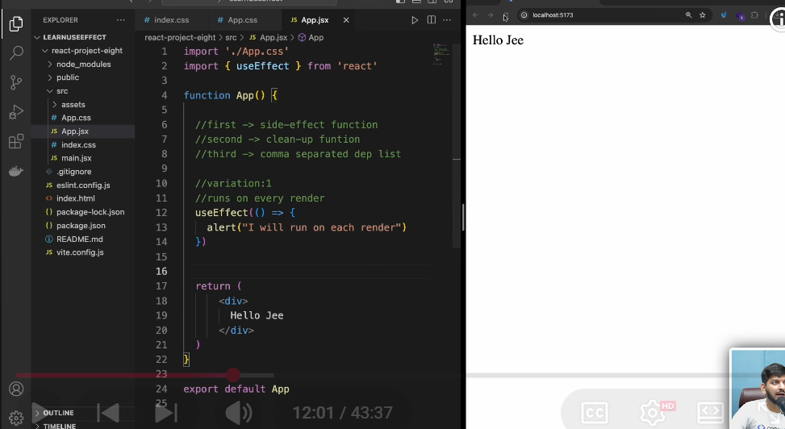

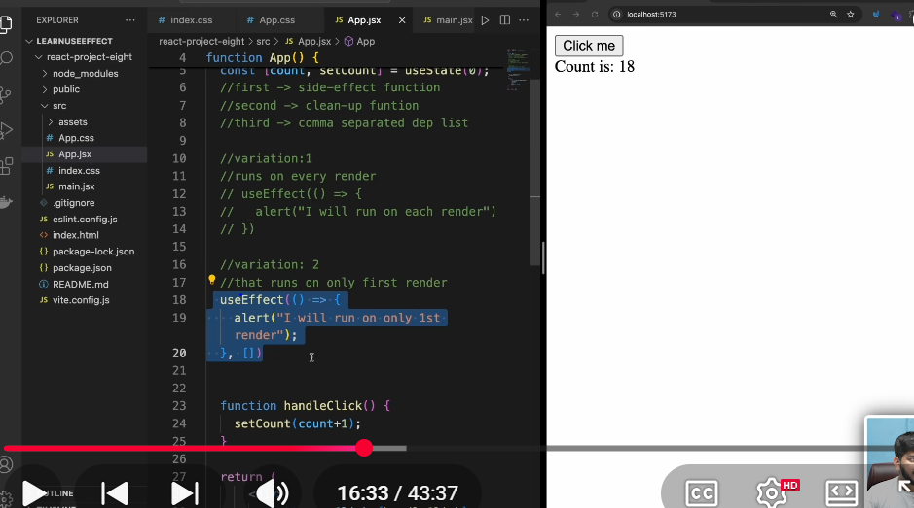
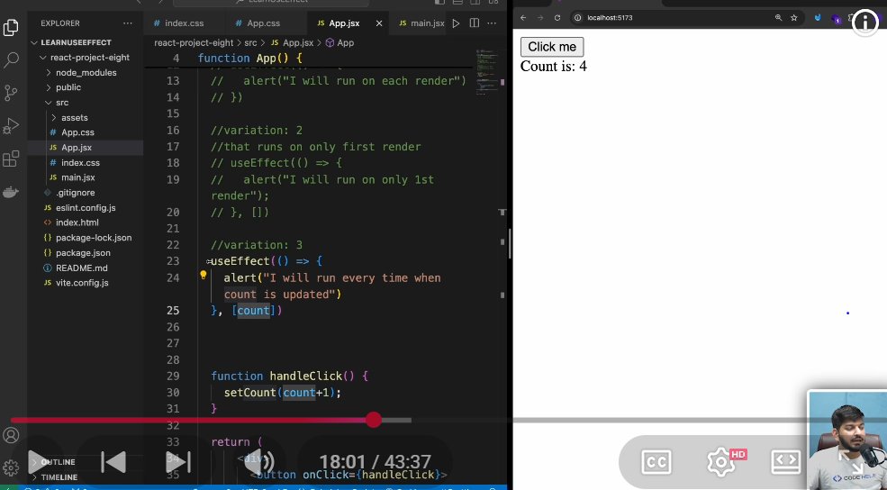

REACT FORM
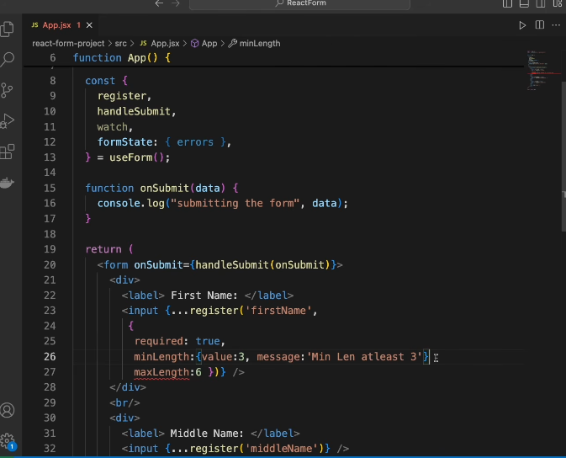

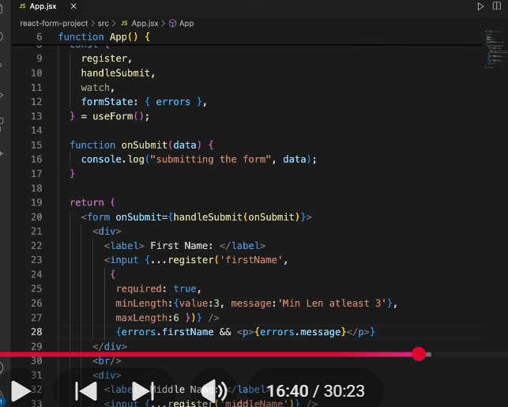

React Hook Form se re-render kyu nahi hote?
Short Answer:
React Hook Form uncontrolled components use karta hai. Ye input ki value ko React state (useState) mein store nahi karta, balki DOM (ref) mein store karta hai. Isliye har key press par component re-render nahi hota.

Normal React form mein re-render isliye hota hai kyunki usme input ko React state se control kiya jata hai (controlled components).

ZOD
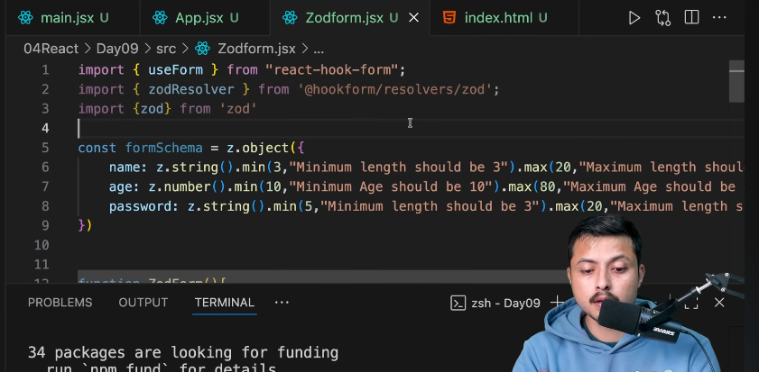

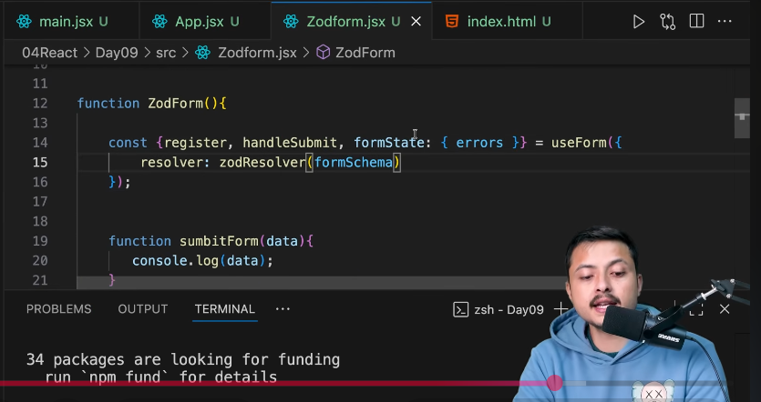

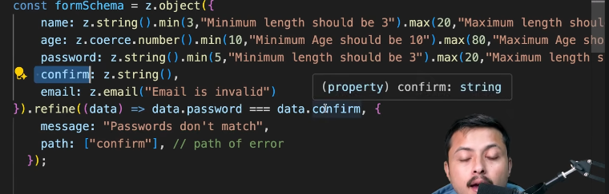

USE CONTEXT
React useContext – In Depth (Interview Level)
What is useContext?
useContext is a React Hook that allows components to access shared data from a Context without passing props through every intermediate component.
It solves the prop drilling problem.

What is Prop Drilling?
Suppose you have the following component tree:
App
│
├── Home
│ │
│ ├── ProductList
│ │ │
│ │ └── ProductCard
│ │ │
│ │ └── BuyButton
Assume the theme value is stored in App.
const theme = "dark";
If BuyButton needs the theme, you would have to pass it through every component:
<App theme={theme}>
<Home theme={theme}>
<ProductList theme={theme}>
<ProductCard theme={theme}>
<BuyButton theme={theme} />
</ProductCard>
</ProductList>
</Home>
</App>
Even though Home, ProductList, and ProductCard don't use the theme, they still receive and forward it.
This is called Prop Drilling.

How useContext Solves It
Instead of passing props manually, React provides a Context that stores shared data.
Any component inside the Provider can access it directly.
ThemeContext
│
Provider (theme="dark")
│
----------------------
│ │
Home Navbar
│
ProductList
│
ProductCard
│
BuyButton
BuyButton can access the theme directly without receiving it as a prop.

How to Use useContext
There are three steps.

Step 1: Create a Context
import { createContext } from "react";
export const ThemeContext = createContext("light");
What does createContext() return?
It returns a Context object.
ThemeContext
Internally, it contains:
ThemeContext.Provider
ThemeContext.Consumer
Today, we usually use useContext() instead of Consumer.

Step 2: Wrap Components with Provider
import { ThemeContext } from "./ThemeContext";
function App() {
return (
<ThemeContext.Provider value="dark">
<Home />
</ThemeContext.Provider>
);
}
The value prop is the data that will be shared.
value="dark"
Every component inside this Provider can access "dark".

Step 3: Access the Context
import { useContext } from "react";
import { ThemeContext } from "./ThemeContext";
function BuyButton() {
const theme = useContext(ThemeContext);
return <button>{theme}</button>;
}
Output:
dark

What Happens Internally?
When React renders:
Provider
value = "dark"
│
▼
React stores the value
│
▼
useContext(ThemeContext)
│
▼
Returns "dark"
React searches upward in the component tree for the nearest Provider.

Complete Example
ThemeContext.tsx
import { createContext } from "react";
export const ThemeContext = createContext("light");

App.tsx
import { ThemeContext } from "./ThemeContext";
import Home from "./Home";
function App() {
return (
<ThemeContext.Provider value="dark">
<Home />
</ThemeContext.Provider>
);
}
export default App;

Home.tsx
import BuyButton from "./BuyButton";
function Home() {
return <BuyButton />;
}
export default Home;

BuyButton.tsx
import { useContext } from "react";
import { ThemeContext } from "./ThemeContext";
function BuyButton() {
const theme = useContext(ThemeContext);
return <button>{theme}</button>;
}
export default BuyButton;

Passing Objects Through Context
Instead of a single value, you can pass an object.
const theme = {
mode: "dark",
color: "black",
};
<ThemeContext.Provider value={theme}>
<App />
</ThemeContext.Provider>
Consume it:
const theme = useContext(ThemeContext);
console.log(theme.mode);
console.log(theme.color);

Sharing State
A common use case is to share both state and its updater.
const [theme, setTheme] = useState("light");
<ThemeContext.Provider
value={{ theme, setTheme }}
>
<App />
</ThemeContext.Provider>
Consume it:
const { theme, setTheme } = useContext(ThemeContext);
<button onClick={() => setTheme("dark")}>
Dark Mode
</button>
Whenever setTheme() updates the state, all components consuming theme receive the updated value.

Does useContext Cause Re-renders?
Yes.
If the Provider's value changes, every component that consumes that context re-renders.
Example:
const [count, setCount] = useState(0);
<CountContext.Provider value={count}>
<Child />
</CountContext.Provider>
const count = useContext(CountContext);
When:
setCount(1);
React updates the Provider value, and all components using CountContext re-render.

Advantages
- Eliminates prop drilling.
- Makes shared data easily accessible.
- Cleaner and more maintainable code.
- Ideal for global data like:
  - Theme
  - Logged-in user
  - Language
  - Authentication
  - App settings

Limitations
- Every consumer re-renders when the context value changes.
- Not ideal for rapidly changing data (e.g., frequently updated counters or animations).
- For complex global state management, libraries like Redux, Zustand, or MobX can provide more granular updates.

REDUX TOOLKIT

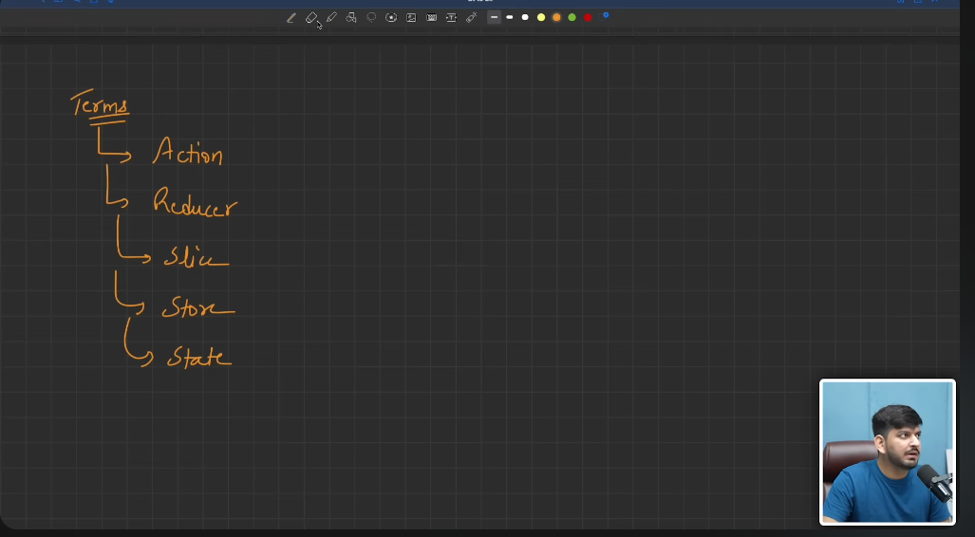

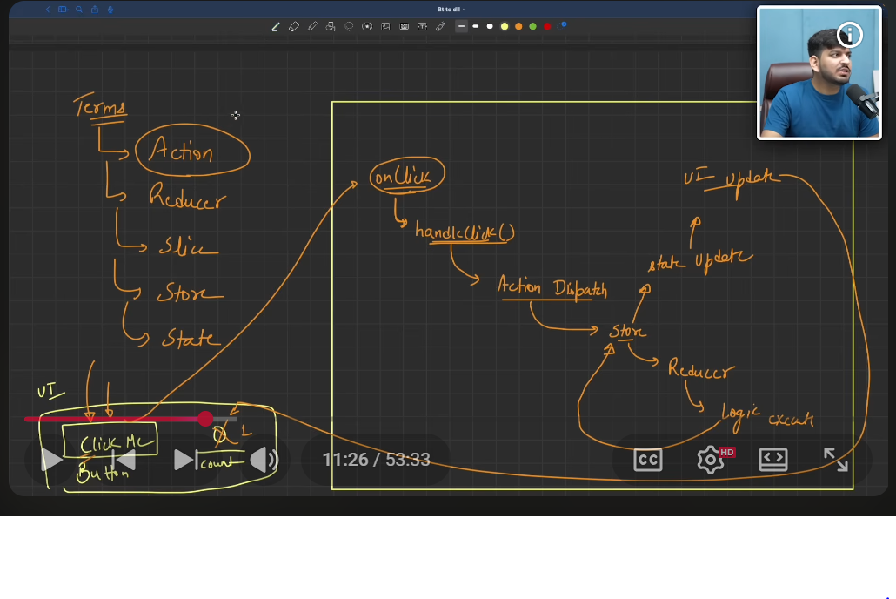

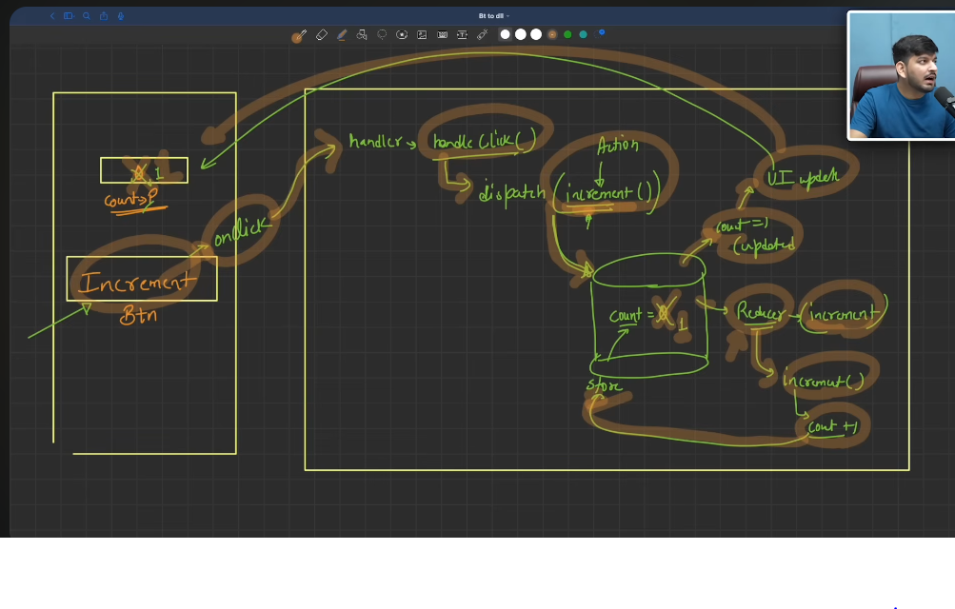

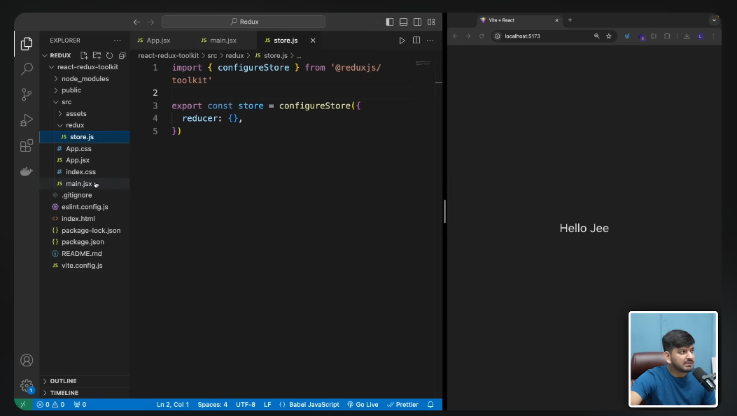

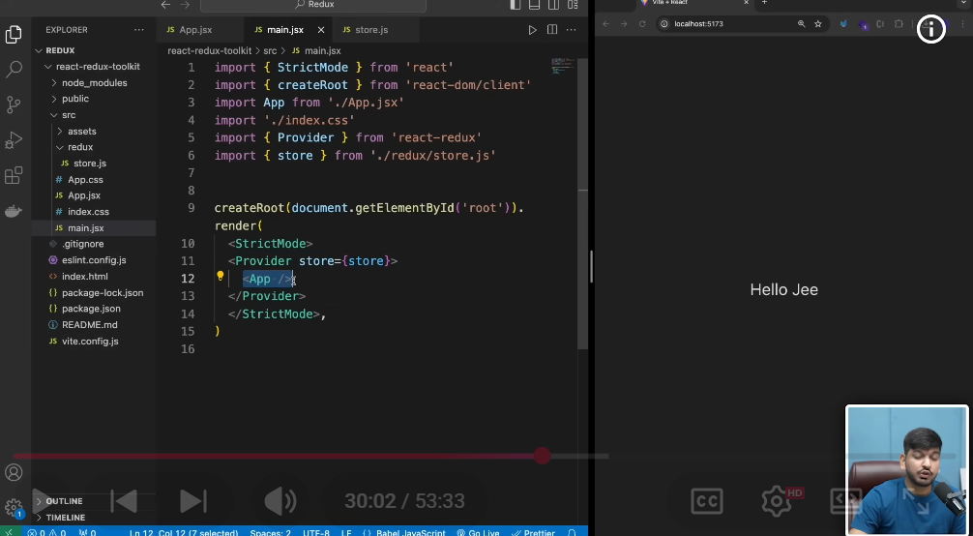

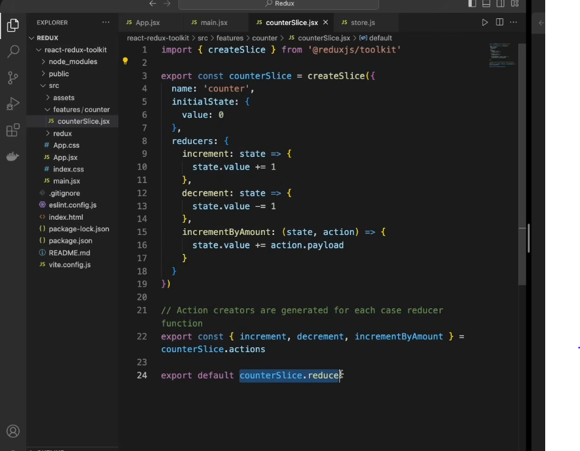

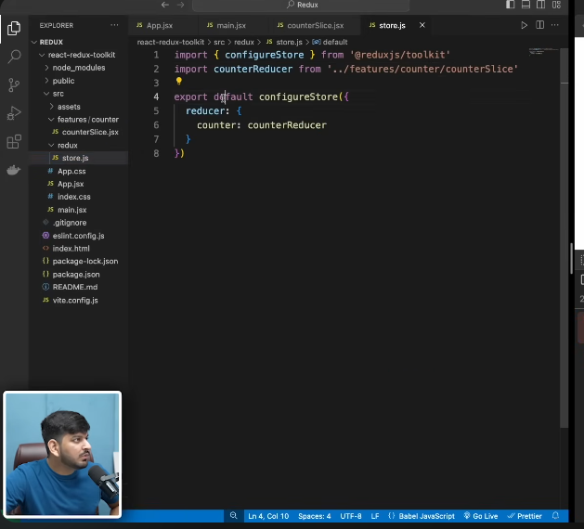

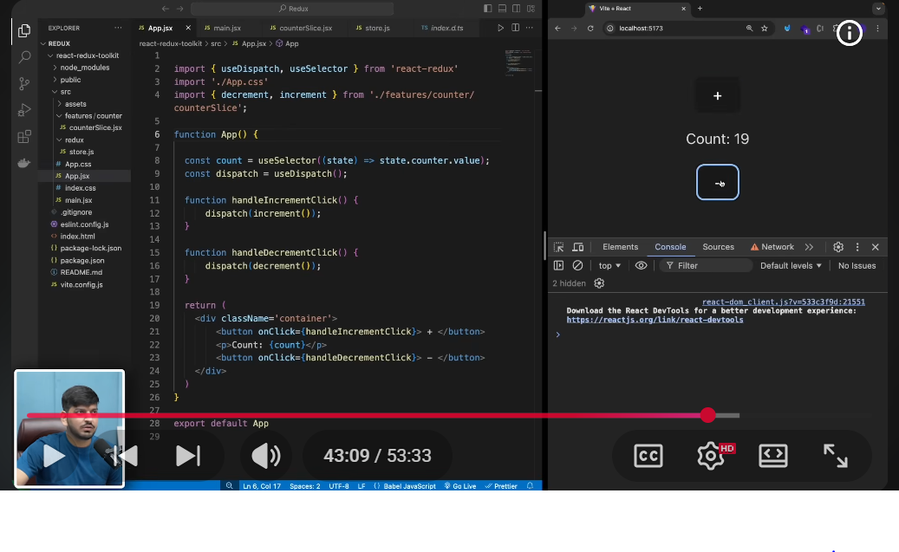

ASYNC THUNK
What is createAsyncThunk?
createAsyncThunk is a function from Redux Toolkit that is used to handle asynchronous operations (API calls, login, fetching data, etc.) in Redux.
Without createAsyncThunk, you have to manually write:
- Loading state
- Success state
- Error state
With createAsyncThunk, Redux automatically generates these action types:
- pending
- fulfilled
- rejected

Why use createAsyncThunk?
Suppose you need to fetch products from an API.
Without createAsyncThunk
Button Click
│
▼
Dispatch Loading
│
▼
Call API
│
├──── Success
│ │
│ ▼
│ Dispatch Success
│
└──── Error
│
▼
Dispatch Error
You have to write all these actions manually.

With createAsyncThunk
Button Click
│
▼
Dispatch AsyncThunk
│
▼
Redux Toolkit
│
├── pending
├── fulfilled
└── rejected
Much less code.

Small React JS Project
We will make a simple Product List App.
Folder Structure
src
│
├── app
│ store.js
│
├── features
│ productSlice.js
│
├── components
│ ProductList.jsx
│
├── App.jsx
├── main.jsx

Step 1 Install
npm install @reduxjs/toolkit react-redux axios

Step 2 store.js
import { configureStore } from "@reduxjs/toolkit";
import productReducer from "../features/productSlice";
export const store = configureStore({
reducer: {
products: productReducer,
},
});

Step 3 productSlice.js
import { createSlice, createAsyncThunk } from "@reduxjs/toolkit";
import axios from "axios";
export const fetchProducts = createAsyncThunk(
"products/fetchProducts",
async () => {
const res = await axios.get("https://fakestoreapi.com/products");
return res.data;
}
);
const productSlice = createSlice({
name: "products",
initialState: {
products: [],
loading: false,
error: null,
},
reducers: {},
extraReducers: (builder) => {
builder
.addCase(fetchProducts.pending, (state) => {
state.loading = true;
})
.addCase(fetchProducts.fulfilled, (state, action) => {
state.loading = false;
state.products = action.payload;
})
.addCase(fetchProducts.rejected, (state, action) => {
state.loading = false;
state.error = action.error.message;
});
},
});
export default productSlice.reducer;

Step 4 main.jsx
import React from "react";
import ReactDOM from "react-dom/client";
import App from "./App";
import { Provider } from "react-redux";
import { store } from "./app/store";
ReactDOM.createRoot(document.getElementById("root")).render(
<Provider store={store}>
<App />
</Provider>
);

Step 5 ProductList.jsx
import { useEffect } from "react";
import { useDispatch, useSelector } from "react-redux";
import { fetchProducts } from "../features/productSlice";
function ProductList() {
const dispatch = useDispatch();
const { products, loading, error } = useSelector(
(state) => state.products
);
useEffect(() => {
dispatch(fetchProducts());
}, [dispatch]);
if (loading) return <h2>Loading...</h2>;
if (error) return <h2>{error}</h2>;
return (
<div>
<h2>Products</h2>
{products.map((item) => (
<div key={item.id}>
<h3>{item.title}</h3>
<p>${item.price}</p>
<hr />
</div>
))}
</div>
);
}
export default ProductList;

Step 6 App.jsx
import ProductList from "./components/ProductList";
function App() {
return (
<div>
<ProductList />
</div>
);
}
export default App;

Output
Products
Laptop
$109
Bag
$40
Watch
$20
Shoes
$55

How createAsyncThunk Works Internally
When this line runs:
dispatch(fetchProducts());
Redux Toolkit automatically dispatches three possible actions based on the API request lifecycle:
1. Pending (API starts)
fetchProducts.pending
State changes to:
loading = true;

2. Fulfilled (API success)
fetchProducts.fulfilled
If the API returns:
[
{
id: 1,
title: "Laptop"
}
]
Then:
state.products = action.payload;
loading = false;

3. Rejected (API fails)
fetchProducts.rejected
State becomes:
loading = false;
error = action.error.message;

Complete Flow
Component Loads
│
▼
dispatch(fetchProducts())
│
▼
createAsyncThunk Starts
│
▼
pending
│
▼
loading = true
│
▼
API Call
│
├──────── Success
│ │
│ ▼
│ fulfilled
│ │
│ ▼
│ products = response.data
│
└──────── Error
│
▼
rejected
│
▼
error = message

Ye Redux Toolkit ka sabse important part hai. Isko line-by-line samajhte hain.
extraReducers: (builder) => {
builder
.addCase(fetchProducts.pending, (state) => {
state.loading = true;
})
.addCase(fetchProducts.fulfilled, (state, action) => {
state.products = action.payload;
})
.addCase(fetchProducts.rejected, (state, action) => {
state.loading = false;
state.error = action.error.message;
});
},

Step 1: extraReducers
extraReducers: (builder) => {
Ye ek function hai jo external actions ko handle karta hai.
Yaha external action hai:
fetchProducts
Kyuki ye createAsyncThunk se bana hai.

Step 2: builder
builder
builder ek object hai jiske through hum batate hain:
"Agar ye action aaye to state ko kaise update karna hai."
Jaise Express me likhte ho:
app.get(...)
app.post(...)
Waise hi Redux me:
builder.addCase(...)

Step 3: Pending
.addCase(fetchProducts.pending, (state) => {
state.loading = true;
})
Jab tum likhte ho:
dispatch(fetchProducts());
Sabse pehle Redux ye action bhejta hai:
products/fetchProducts/pending
Us waqt callback chalega:
(state) => {
state.loading = true;
}
State:
{
products: [],
loading: true,
error: null
}
UI me:
{loading && <h2>Loading...</h2>}
Output:
Loading...

Step 4: API Call
Ab API call hoti hai.
await axios.get(...)
Maan lo response aaya:
[
{
id:1,
title:"Laptop"
},
{
id:2,
title:"Phone"
}
]

Step 5: Fulfilled
Ab Redux automatically ye action dispatch karta hai:
products/fetchProducts/fulfilled
Ye callback chalega:
.addCase(fetchProducts.fulfilled, (state, action) => {
state.products = action.payload;
})
Yaha
action.payload
ke andar API ka response hota hai.
Matlab:
action.payload
=
[
{
id:1,
title:"Laptop"
},
{
id:2,
title:"Phone"
}
]
Fir
state.products = action.payload;
ho jata hai.
Ab state:
{
products:[
{id:1,title:"Laptop"},
{id:2,title:"Phone"}
],
loading:true,
error:null
}
⚠️ Yahan ek mistake hai.
Tumhare code me:
.addCase(fetchProducts.fulfilled, (state, action) => {
state.products = action.payload;
})
Yahan
state.loading = false;
bhi hona chahiye.
Correct code:
.addCase(fetchProducts.fulfilled, (state, action) => {
state.loading = false;
state.products = action.payload;
})
Nahi to loading hamesha true rahegi.

Step 6: Rejected
Agar API fail ho gayi.
Example:
404
Network Error
500
Redux automatically dispatch karega
products/fetchProducts/rejected
Fir
.addCase(fetchProducts.rejected, (state, action) => {
state.loading = false;
state.error = action.error.message;
})
Yaha
action.error.message
ho sakta hai
Network Error
State:
{
products:[],
loading:false,
error:"Network Error"
}
UI
if(error){
return <h1>{error}</h1>
}
Output
Network Error

Complete Flow
dispatch(fetchProducts())
│
▼
pending
│
▼
loading = true
│
▼
API Call
│
┌────┴─────┐
│ │
Success Error
│ │
▼ ▼
fulfilled rejected
│ │
▼ ▼
products error message
= data loading=false
loading=false

builder.addCase() ka syntax
builder.addCase(action, callback)
- First argument (action): Kaunsa action handle karna hai (jaise fetchProducts.pending).
- Second argument (callback): Jab wo action aaye, tab state ko kaise update karna hai.
Example:
builder.addCase(fetchProducts.pending, (state) => {
state.loading = true;
});
Matlab:
Agar fetchProducts.pending action aaye, to loading ko true kar do.

